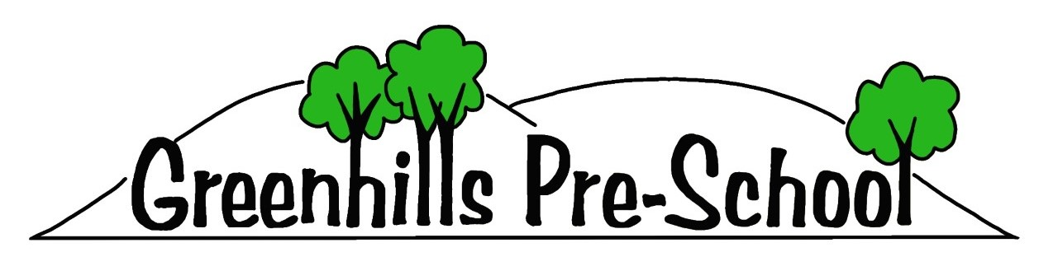
Registered Charity No. 1131512

Child’s full name: _______________________________________________________________
Name known as: _____________________ Date of Birth. ______________
Gender (male/female) _____________
Address: _________________________________________________________________________
________________________________________________Postcode: _______________________

Parent 1 name: _________________________________________________________________
Does this parent have parental responsibility? Yes/No
Address if different to the child: ___________________________________________________
Email _____________________________________________________________
Daytime phone number: ________________________ Mobile: ________________________
Occupation (if willing to share): ___________________________________

Parent 2 name: _________________________________________________________________
Does this parent have parental responsibility? Yes/No
Address if different to the child: ___________________________________________________
Email _____________________________________________________________
Daytime phone number: ________________________ Mobile: ________________________
Occupation (if willing to share): ___________________________________

Parental responsibility is defined by the Children’s Act 1989. People that have parental responsibility are: birth mothers (except where the child has been adopted) birth fathers if they were married to the mother at the time of the child’s birth and all birth fathers if they and the birth mother register the birth of their child together from 1st December 2001.

Emergency contacts, in addition to parents, and people authorised to collect the child (must be over 16 years of age):
1.
Name: | Relationship to child:
Daytime phone number: | Mobile:
2.
Name: | Relationship to child:
Daytime phone number: | Mobile:
In an emergency, if a child’s parents or emergency contacts cannot be reached then we will call Children’s Social Care or the police.

In the event that your are unable to collect your child from pre-school, please provide us with a password of your choice. We can then ask for the password when the allocated person comes to collect your child.
My childs password is:

Personal details
What language(s) are spoken at home? ____________________________________
If English is not the main language spoken at home, will this be your child’s first experience of being in an English – speaking environment? Yes/No
If so, discuss and agree with the key person how you will support your child when settling in.

Does your child have any special needs or disabilities? Yes/No
Details ________________________________________________________
Does your child have an Education and Health Care Plan? Yes/No
What special support will he/she require in our setting?
________________________________________________________________________________

Do you have a health visitor? Yes/No
Name __________________________ Based at _________________________
Telephone ___________________________

Has your child had their 2 year check? Yes/No
If yes, please provide us with a copy.
Are you willing to share information from your child’s health record? (red book)
Yes/No

Has your family had involvement from the social care department? Yes/No
Please tick all that apply:
- Early Help
- Social Worker
Professional name: __________________________ Based at ________________________
Telephone __________________________

NB If your child has a protection plan, please provide us with more details separately so we can keep them in your child’s file.

Medical Information
Name of Doctors Surgery ___________________________ Telephone __________________
Name of Doctor ______________________________
Does your child have any health issues that we should be aware of?

Immunisations.
Is your child allergic to anything? Do they have an allergy action plan?

Does your child have any special dietary needs or preferences?

Please tick the boxes to show that your child has had the following –
Diphtheria, Whooping cough, Tetanus, Polio, Hib (1)
Diphtheria, Whooping cough, Tetanus, Polio, Hib. (2)
Diphtheria, Whooping cough, Tetanus, Polio, Hib. (3)

Measles, Mumps. Rubella (MMR)

Pre – School booster (Diphtheria, Tetanus, Polio)

Consent Forms

Hhhhhhhhhh
Relationship to child:
Date:
Signed:

I give permission for _________________________ (child’s name) to go on small supervised outings. We go on regular walks around our local community as part of our curriculum.

Short trips consent
Relationship to child:
Date:
Signed:
Please note:
- The authorising signatory for the above consent must have legal “parental responsibility”.
- Every attempt will be made to contact the parents/guardians of the given emergency contact.

In the event of________________________ (child’s name) needing emergency medical treatment,
I give/do not give permission for a suitably qualified First Aider to administer First Aid to my child, or take to A+E, or call for medical assistance, or an ambulance if necessary, and to sign on my behalf any consent forms required by medical authorities, if they know that it would not be advisable to wait for my own signature.
Medical emergency consent

G

G

Photography consent
I give permission for Greenhills Pre-school to photograph my child _______________________ (insert name) for the following purposes (please tick):

- Child records (for internal purposes)
- Baby’s Days (where other parent’s can view)
- Displaying on walls of pre-school
- Newspaper articles
- Staff coursework
- Social Media (Greenhills Facebook page & website)

Greenhills Pre-school will not take or use photographs in an inappropriate manner. Consent can be withdrawn at any time.

Signed:
Date:
Relationship to child:
Parent Declaration: Use of Photographs on BabysDays
I, the undersigned parent/carer, understand and agree to the following conditions regarding the use of photographs shared through the BabysDays communication app:
- No Screenshotting — I will not screenshot, screen-record, copy, or otherwise capture any images that include children other than my own.
- No Downloading — I will not download, save, or store photographs of any child other than my own from the BabysDays platform.
- No Sharing Online — I will not repost, upload, share, or distribute photographs of any child other than my own on social media, messaging apps, websites, or any online platform.
- Respect for Privacy — I understand that these measures protect the privacy, dignity, and safeguarding rights of all children in the setting.

By signing this declaration, I confirm that I will follow these expectations at all times while using BabysDays.

Signed:
Date:
Relationship to child:

Information sharing policy
In accordance with GDPR regulations, we are obligied to gain your permission to hold the information that you have provided to us.
I have read the above and understand that there may be circumstances when information will be shared without my consent
Signed:
Date:
Relationship to child:
We recognise that parents have a right to know that information they share will be regarded as confidential as well as be informed about the circumstances, and reasons, when we are obliged to share information.
We are obliged to share confidential information without authorisation from the person who provided it or to whom it relates if it is in the public interest. That is when: it is to prevent a crime from being committed or intervene where one may have been or to prevent harm to a child or adult; or not sharing it could be worse than the outcome of having shared it.
The decision should never be made as an individual, but with the back- up of management committee officers. The three critical criteria are: Where there is evidence that the child is suffering, or is at risk or suffering, significant harm. Where there is reasonable cause to believe that a child may be suffering or at risk of suffering significant harm. To prevent significant harm arising to children and young people or serious harm to adults, including the prevention, detection and prosecution of serious crime.

