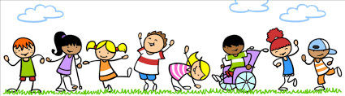
All about me Personal & Family Details

This is me
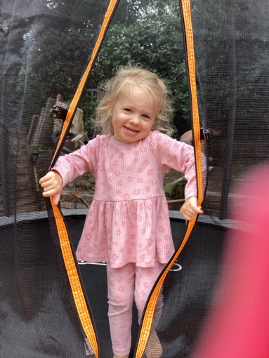
I live with: mummy, Bobby , Bonnie , daddy
Songs & rhymes I like to sing: Baby shark , finger family , sleeping bunnies , frozen , ring a roses , what’s in the bag , incy wincy spider .

Stories & characters I like: peppa pig , Elsa and Anna , bluey ,
Position in family: I am the youngest

My favourite food is: pasta , crab sticks , cucumber , blueberries , grapes

My name is:
I can drink from a cup- yes

I like to drink: water

Lola-Bea Bradley
Toys I like to play with: toy kitchen and food , small world , Barbie’s , baby dolls , play doh,
My birthday is:
13th October 2021
Special things I want you to know:
Things I don’t like or that frighten me: spiders

My first language is: English

I can / my family can also speak:

Festivals or special occasions celebrated at home:

Games I like to play outside: ball games , sand , mud kitchen , water , running , slides

I currently attend: pollyannas day nursery because my mummy works there .

All about me

These people are important to me..... (This could include family, childminder, people at nurseries, friends grown up or small, pets and many others)

Name- Bobby
Because- he is my big brother and he helps me all the time.
Name – Mummy
Because – she looks after me and gives me cuddles and kisses.

Name – daddy
Because – he gives me cuddles and kisses and makes me laugh.

Name – Bonnie
Because – she is my big sister and she plays with me and helps me all the time .
Name – nanny
Because – she looks after me and gives me cuddles and kisses .

This is my week.....
Thursday: I go to another nursery with my mummy because she works there and then we go and pick Bonnie up from school and then home.
Wednesday: I go to Greenhills and then my mummy picks me and Bonnie up to go home.
Tuesday: I go to another nursery with my mummy because she works there and then we go and pick Bonnie up from school and then home.
Monday: I go to Greenhills and then my mummy picks me and Bonnie up to go home.

Sunday:we usually go to see nanny and grandma and grandad.
Friday: I go to Greenhills and then my mummy picks me and Bonnie up to go home.
Saturday: we usually go on a day out somewhere nice .

All about me Helpful Information

Communication and Language
Does your child talk confidently and clearly? Yes mostly
Does your child talk using simple sentences? Most of the time
Has your child been referred to Speech and Language therapy? No

Personal, Social and Emotional
Does your child play happily with other children? Sometimes but does struggle to share
Is your child happy to be left with another adult? Sometimes

Physical Development
Is your child beginning to be independent in self-care? Toileting, washing and drying hands etc.
Details: she has been doing so well out of nappies through the day , may have the odd accident at first as she may be shy and nervous but once she gets used to her surroundings and people she should be fine , she usually says but may need prompting now and then. Can’t wipe herself . Can wash and dry hands fine .

Is your child beginning to show a preference for a dominant hand
Mainly uses her left hand

